**Overfitting, Underfitting and Model Selection**

**TOTAL POINTS 2**

1.Question 1

what model should you select

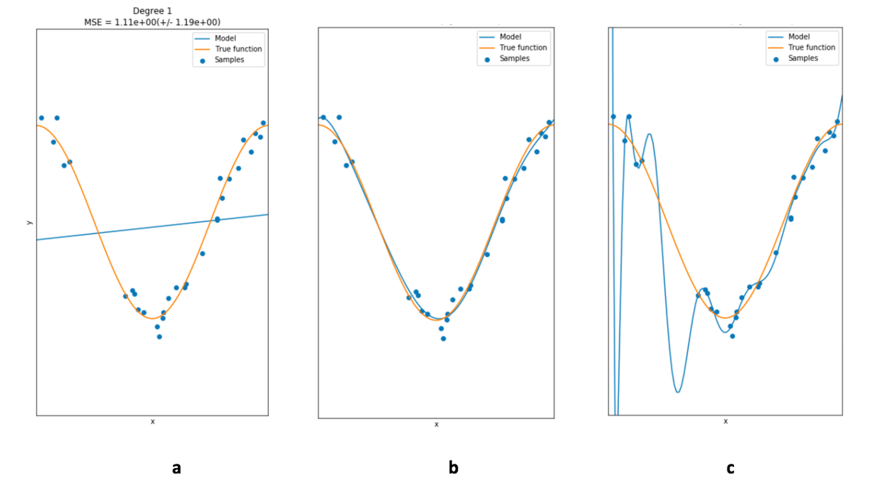



b



a



c

1 point

2.Question 2

what model would have the lowest training error





a



b



c

1 point